AI ASSISTED CODING

# Name: Arukonda Akhil

# Roll no:2403a51279

## Question 1: create a python function that converts an amount from one currency to another using exchange rates stored in a dictionary. use few shot prompting

VS CODE:

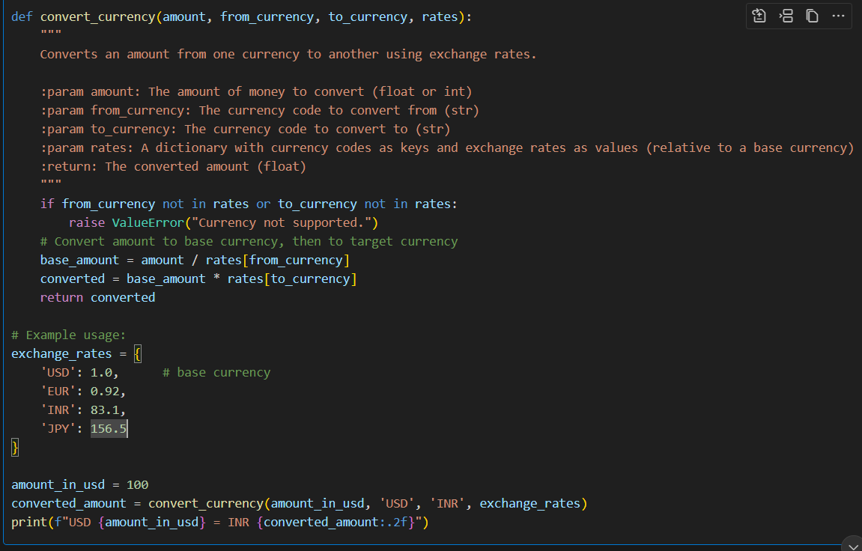

Output:



COPILOT CODE:

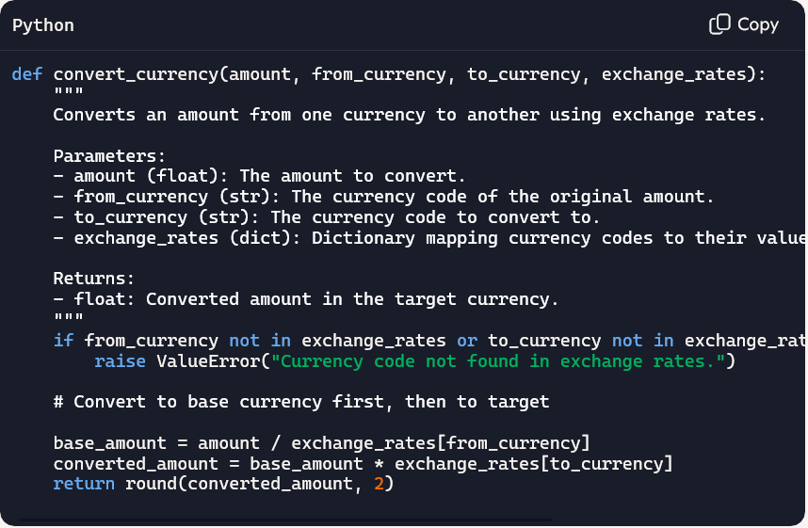

Output:

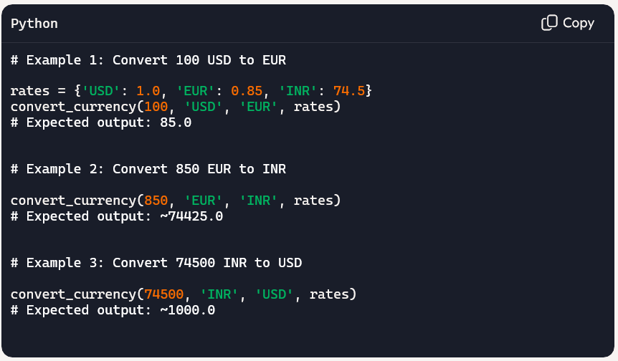

## Question 2: Write a Python program to extract all email addresses from a block of text using regular expressions. GitHub Copilot along with VS Code. Use zero shot prompting

VS CODE:

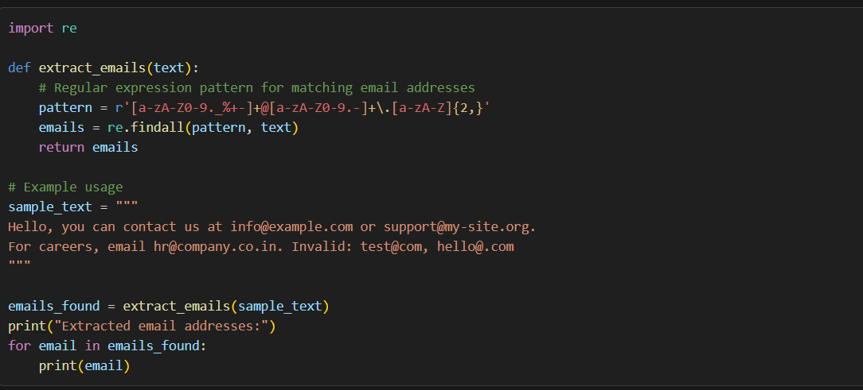

OUTPUT:

COPILOT CODE:

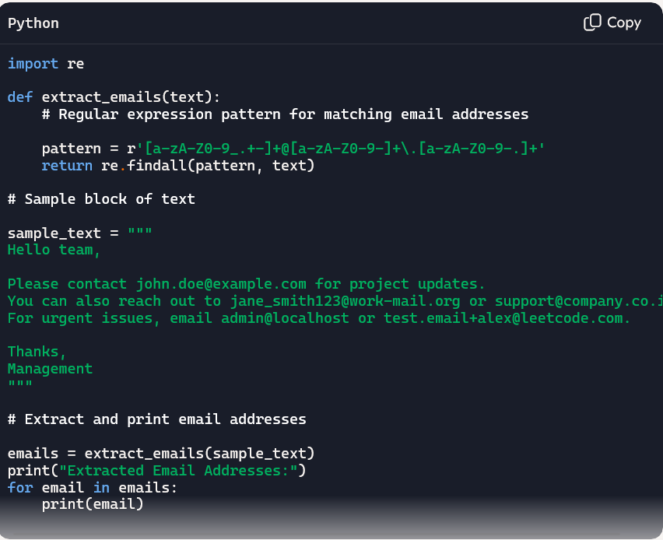

OUTPUT:

## Question 3: Given a list of movies with their genres, Write a Python function that recommends movies based on a user's preferred genre. Use the Cursor AI tool. Use few shot prompting.

VS CODE:

OUTPUT:

COPILOT CODE:

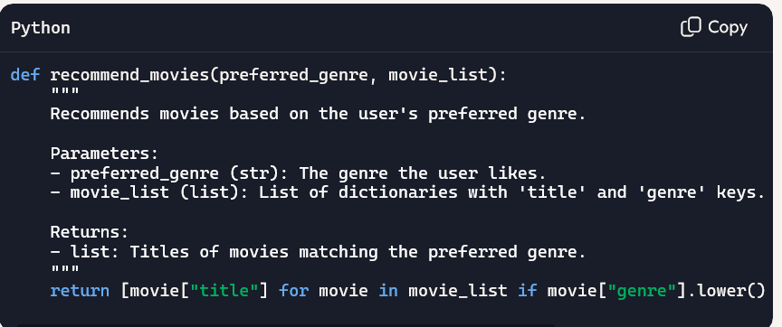

OUTPUT:

## Question 4: Write Python code that reads a CSV file containing student names and marks in 3 subjects. Calculate the total and average marks for each student. Use the Cursor AI tool.

CODE:

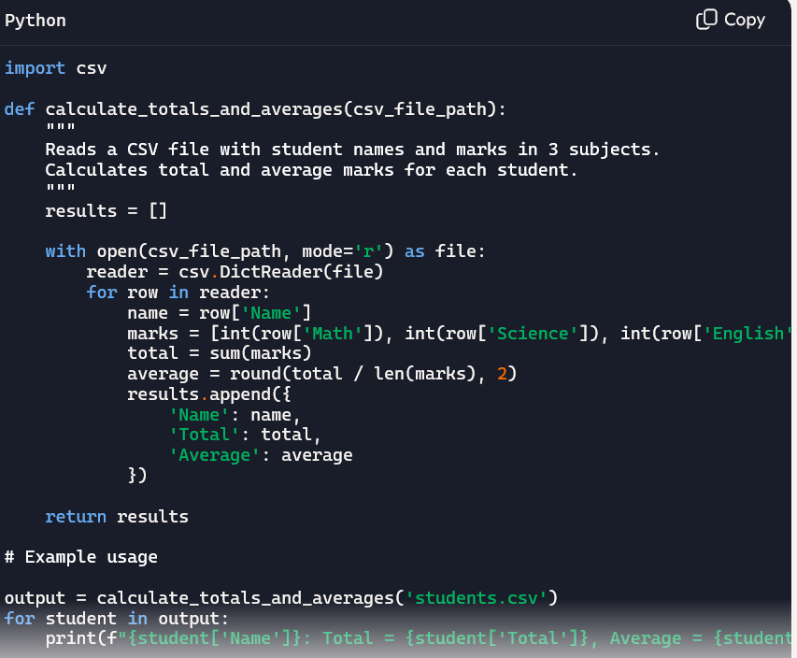

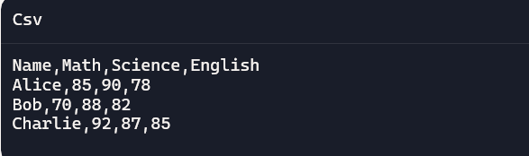

OUTPUT:  
